Dear Zuckerman MR Platform Principle Investigator:

The Zuckerman MR Platform uses iLab’s Core Facility Management software, an online system to streamline the process of ordering and billing for core service requests. Please find instructions below on how to use the system and to learn about your specific responsibilities.

**Logging in:**

1. Go to https://cumc.corefacilities.org
2. Login with your UniID login
   1. If you are taken to a registration page, please contact Jennifer Williamson [jlw61@cumc.columbia.edu](mailto:jlw61@cumc.columbia.edu).
3. Look for the link in the left-hand menu that says **'my labs'**. Hover-over and select your lab to go to your lab management page.

**Responsibilities in iLab:**

As a Principal Investigator, you have a few new responsibilities to enable your research team to order services from the cores and make equipment reservations, specifically:

* Accepting users into your lab (see item 1 below)
* Assigning chart strings to lab members (see item 2 below)
* Adding additional chart strings to your lab, if applicable (see item 3 below)
  + URs must be approved by Jennifer Williamson [jlw61@cumc.columbia.edu](mailto:jlw61@cumc.columbia.edu) who will verify your chart string with your administrator.
* Disable chart strings that are not used and/or enable them to be used (see item 4 below)
* Approving certain core service requests (see item 5 below to set the threshold)
* Managing lab members and their rights (see item 6 below)

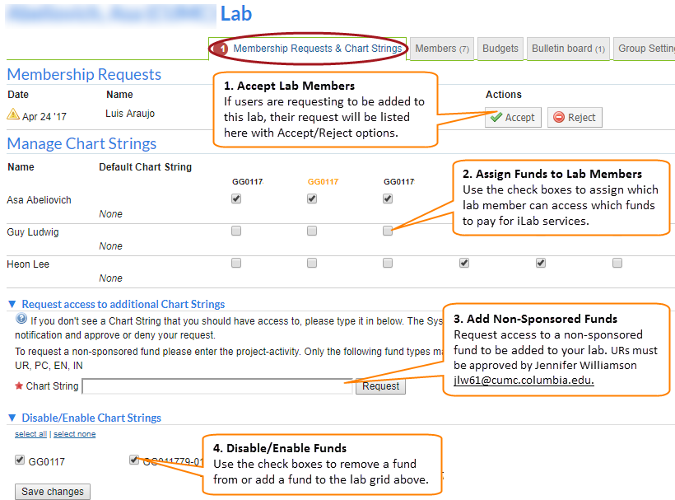

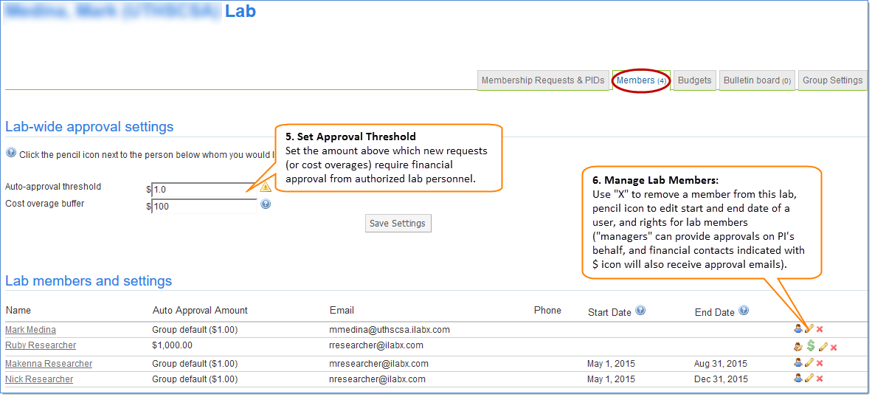

If you would prefer to delegate these notifications and approvals to specific member(s) of your lab, for example your lab manager or your department administrator, please email [ilab-support@agilent.com](mailto:ilab-support@agilent.com) with their name and email.

**Additional Help**

Detailed instructions are also available on the [iLab Help Site](http://help.ilab.agilent.com/core-facilities-lab-administrators/). For any questions not addressed in the Help Site, click on the “HELP” link in the upper right hand corner or contact [ilab-support@agilent.com](mailto:ilab-support@agilent.com).

Sincerely,

The Columbia iLab Team